# CULTURAL PROGRAM

**CONTENTS**

SCHEDULED FOR THE CULTURAL FEST **Error! Bookmark not defined.**

INDOOR GAMES **Error! Bookmark not defined.**

OUTDOOR GAMES 5

MIS-MATCH DAY 5

BOLLYWOOD DAY **Error! Bookmark not defined.**

HALLOWEEN DAY **Error! Bookmark not defined.**

TRADITIONAL DAY **Error! Bookmark not defined.**

FRESHERS PARTY **Error! Bookmark not defined.**

(BATCH 2021 & 2022) **Error! Bookmark not defined.**

FAREWELL PARTY 2023 **Error! Bookmark not defined.**

(BATCH 2017 - 2018) 16

**Report Done by**

Ar. Kajal Sawant, Ar. Gayatri Khaire

# SCHEDULED FOR THE CULTURAL FEST

Annual Cultural Fest 2023 of our college is an event that makes one learn about an architecture student’s journey through the days of education. It is an event where display of activities with cultural blend had taken places.

This program was celebrated with full enthusiasm for a week and was held on 4th and 10th March 2023.

Students conduct cultural week with the help of cultural coordinator and one of the faculty member. The program includes indoor & outdoor games, music, various days, dance, food etc. for teachers, staff and students.

This full week was greatly celebrated with a blend of various cultures and activity.

|  |  |  |
| --- | --- | --- |
| **SR.NO** | **EVENT** | **DATE** |
| 1. | Indoor Games | 04/03/2023 |
| 2. | Outdoor Games | 05/03/2023 |
| 3. | Mis-Match Day | 06/03/2023 |
| 4. | Bollywood Day | 08/03/2023 |
| 5. | Halloween Day | 09/03/2023 |
| 6. | Traditional Day | 10/03/2023 |
| 7. | Freshers Party | 10/03/2023 |
| 8. | Farewell Party | 11/03/2023 |

# **INDOOR GAMES**

The sports day event was celebrated for two days. The first day i.e. 04/03/2023 was dedicated to indoor games. Different indoor games like snake and ladder, cheese, ludo, three-leg race etc. was arraged for students. Students had worked out on time schedules and equipments requirement for all the games. Large amount of students had participated in all the games. Faculty also participated in the event where students were playing and having fun**. The prize distribution for all the sports day winner was done on fresher’s and farewell party.**

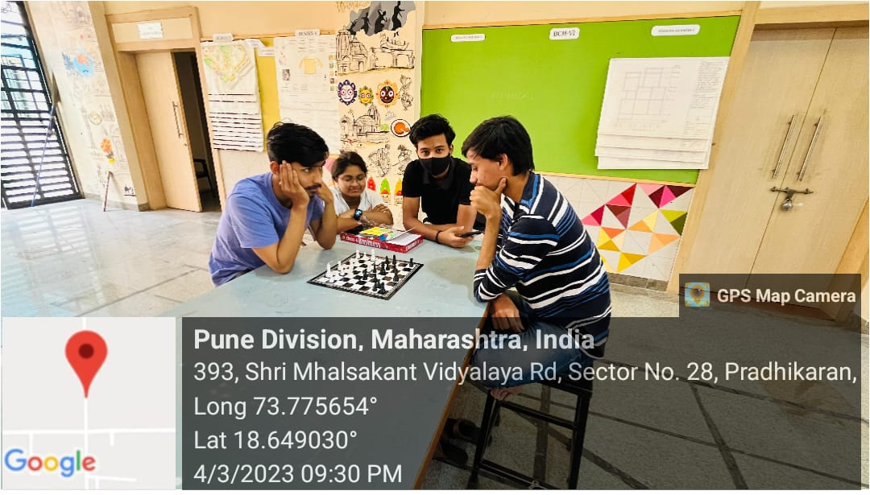

# C:\Users\ARCH\Downloads\WhatsApp Image 2024-01-17 at 1.11.26 PM.jpeg

**OUTCOME**

The two-day sports day event held at PDEA College of Architecture was a resounding success, fostering a sense of camaraderie and healthy competition among students and faculty members.

**Day 1:** Indoor Games On the first day of the event, a variety of indoor games were organized, including snake and ladder, cheese, ludo, and three-leg race. Students took active participation in planning the event, working out time schedules, and arranging the necessary equipment for each game. The enthusiastic involvement of students contributed to the smooth execution of the games.

Faculty members also joined in the fun, participating alongside students and cheering them on. The event provided an opportunity for students and faculty to bond outside of the classroom, promoting a sense of community within the college.

**Day 2:** Prize Distribution The winners of the sports day event were recognized and awarded during the fresher’s and farewell party, adding an element of excitement and anticipation to the celebration. The prize distribution ceremony served as a fitting conclusion to the event, acknowledging the efforts and achievements of the participants.

Overall, the sports day event was not only about physical activity and competition but also about fostering teamwork, sportsmanship, and a sense of belonging within the college community. It provided a platform for students and faculty to come together, celebrate their accomplishments, and create lasting memories.

# **OUTDOOR GAMES**

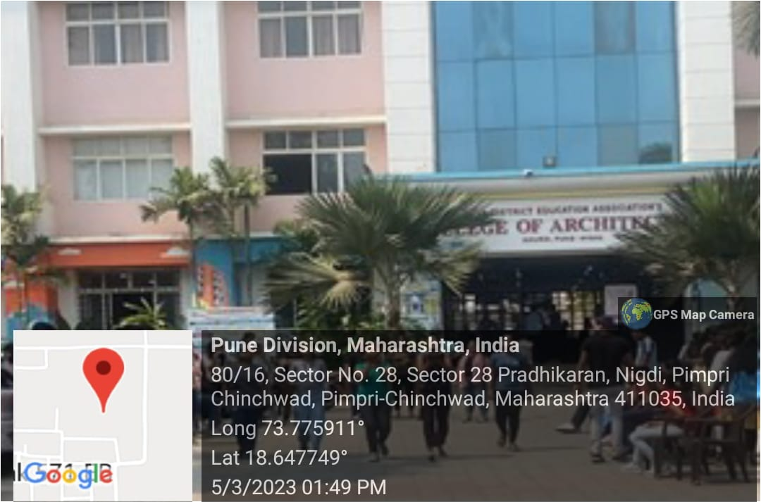The sports day event was celebrated for two days. The second day i.e. 05/03/2023 was dedicated to outdoor games. Different outdoor games like tug of war, crickek, kho-kho etc, was arraged for students. Students had worked out on time schedules and equipments requirement for all the games. Large amount of students had participated in all the games. Faculty also participated in the event where students were playing and having fun**. The prize distribution for all the sports day winner was done on fresher’s and farewell party.**

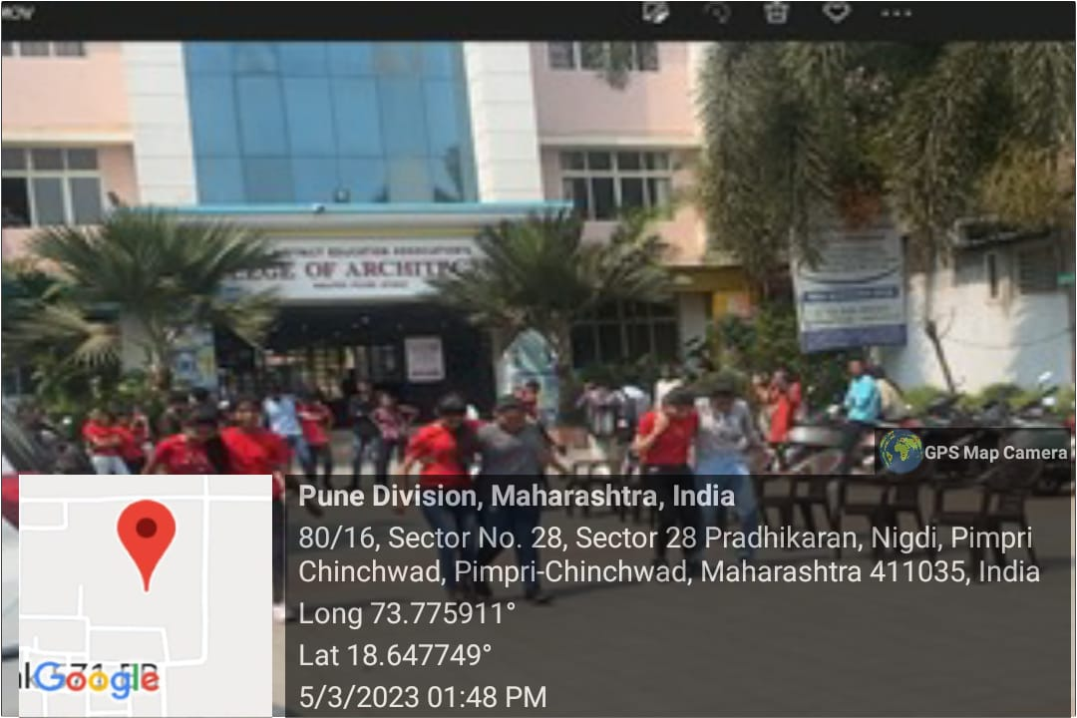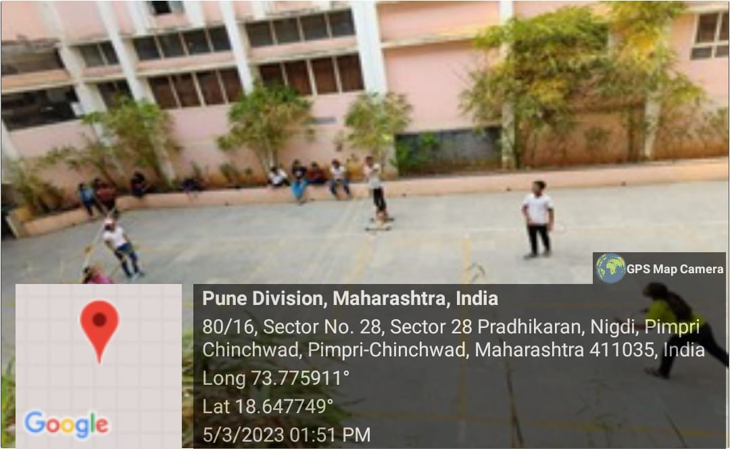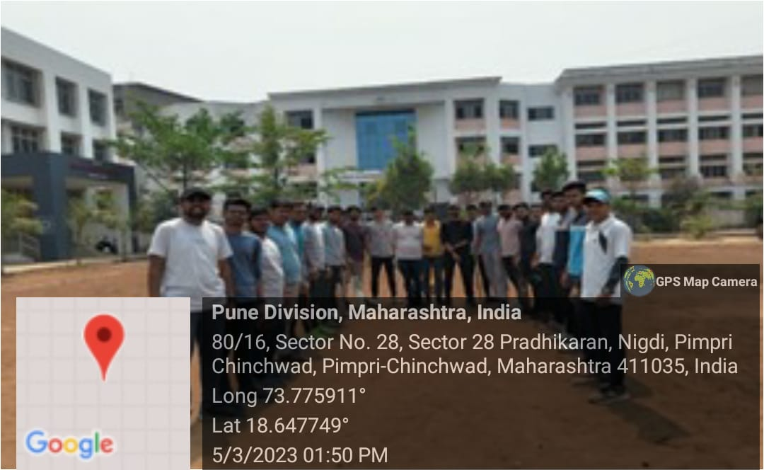

# 

**OUTCOME**

The two-day sports day event held at PDEA College of Architecture concluded with a thrilling day of outdoor games, fostering a sense of teamwork, competitiveness, and enjoyment among students and faculty members.

Day 2: Outdoor Games The second day of the event featured a variety of outdoor games, including tug of war, cricket, kho-kho, and more. Students enthusiastically participated in these games, showcasing their athletic abilities and spirit of sportsmanship. The meticulous planning by students ensured that the event ran smoothly, with proper time schedules and equipment arrangements for each game.

Faculty members actively engaged in the event, joining students in the games and cheering them on from the sidelines. This participation from faculty further enhanced the sense of camaraderie and unity among everyone present.

Prize Distribution: The winners of the sports day event were acknowledged and rewarded during the fresher’s and farewell party, adding excitement and anticipation to the celebration. The prize distribution ceremony served as a fitting conclusion to the event, recognizing the outstanding performances and efforts of the participants.

Overall, the sports day event was a resounding success, providing students and faculty with an opportunity to bond, compete, and celebrate together. It not only promoted physical activity and healthy competition but also reinforced the sense of community and belonging within the college

**REPORT ON MIS-MATCH DAY**

**Date:** 06 March 2023

**Organized by:** PDEA’S College of Architecture

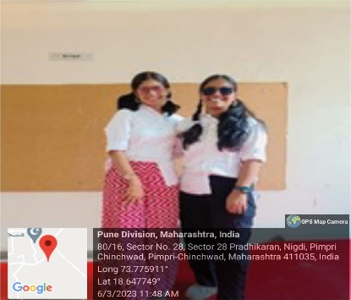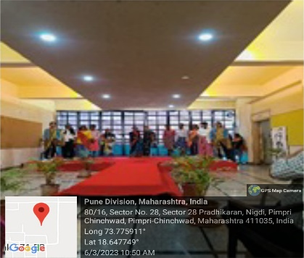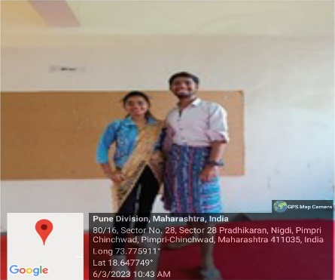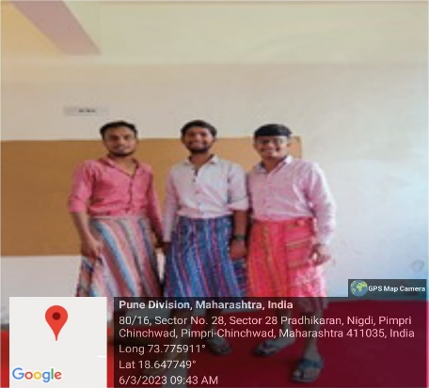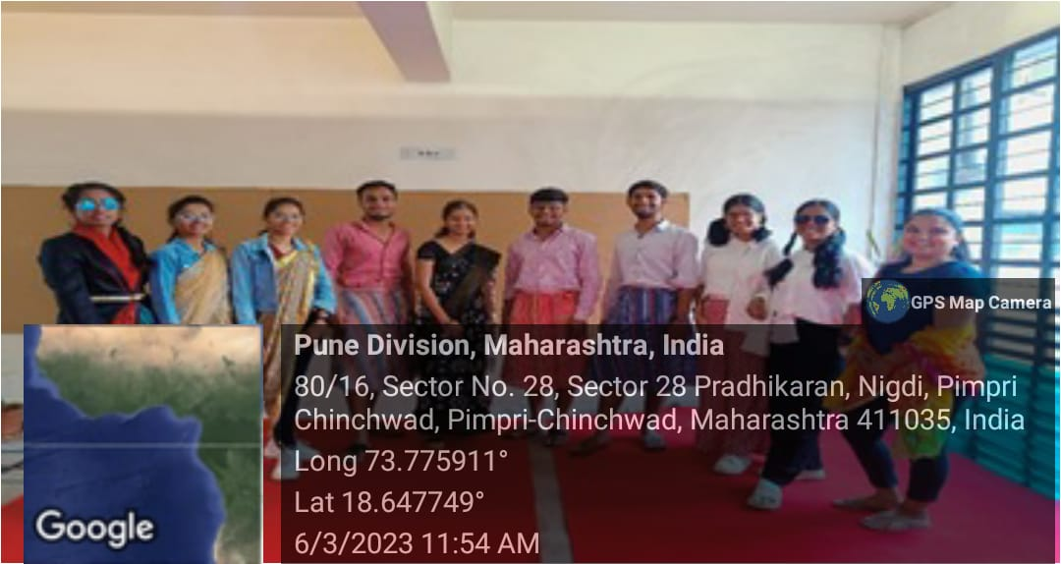**Brief:** Mis-Match day was celebrated on 06/03/2023 (Monday) with many activites like games. Students had dressed up in different themes and also did the twinning in it. Students had worked out the backdrop of the stage in really simpliestic and great aspects. Faculty also participated in the event where students were playing games and also helped them in there dressing. Students came up with new and creative ideas using their imagination and wore clothes to reflect their mismatch personalities. They wore different pairs of socks and shoes. **The day had to end up with a ramp walk which was organised by students for the faculties as well as for themselves**

**Photograph of Miss-Match Day**

**OUTCOME**

Mismatch Day, celebrated on 06/03/2023, was a vibrant and creative event that showcased the unique personalities and creativity of students at PDEA College of Architecture.

Theme Dress-Up and Twinning: Students enthusiastically embraced the theme of Mismatch Day by dressing up in various creative and mismatched outfits. They showcased their imaginative ideas through mismatched clothing combinations, such as different themes, colors, and patterns. Twinning was also observed among students, adding a fun and cohesive element to the event.

Faculty Participation: Faculty members actively participated in the event, not only by overseeing the activities but also by joining students in games and dressing up in mismatched attire. Their involvement contributed to the lively atmosphere and fostered stronger bonds between students and faculty.

Backdrop and Stage Setup: Students showcased their artistic skills by designing a simplistic yet visually appealing backdrop for the stage. The backdrop added to the ambiance of the event and provided a colorful backdrop for various activities and performances.

Creative Ideas and Ramp Walk: Students showcased their creativity and imagination through their mismatched outfits, incorporating elements such as different pairs of socks and shoes. The day culminated with a lively ramp walk, where students and faculty members had the opportunity to strut their stuff and showcase their unique styles.

Overall, Mismatch Day was a successful and enjoyable event that allowed students to express themselves creatively, fostered camaraderie among peers, and provided a memorable experience for everyone involved.

**REPORT ON BOLLYWOOD DAY**

**Date:** 08 March 2023

**Organized by:** PDEA’S College of Architecture

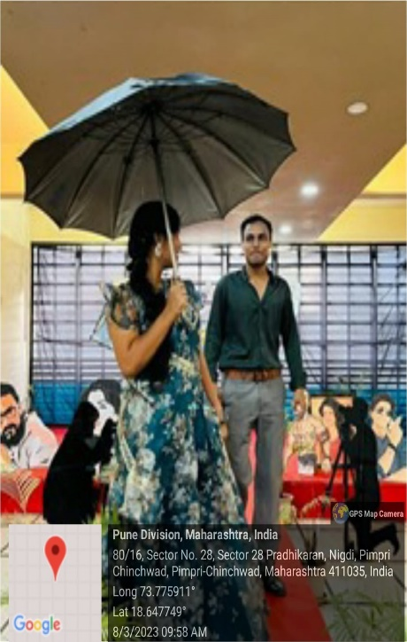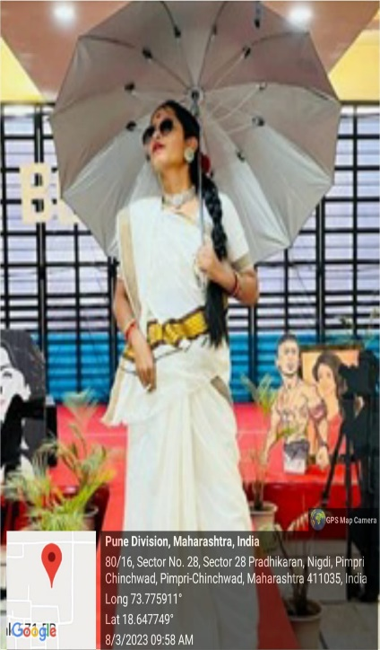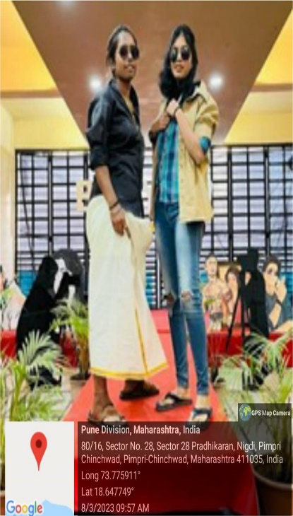**Brief:** Bollywood day was celebrated on 08/03/2023 (Wednesday) with many activites like games, musical chair etc. The idea of celebrating the Indian film industry originated with the founder of the Bombay Film Society, Pramod Khanna. Students participated by dressing up as their favorite characters from popular Bollywood films. The event was lively as students modeled their costumes on the ramp. Popular characters such as Monjolika, Munna Bhai, and Gangu Bai were seen among the students. The celebration was a huge success and allowed students to express their creativity and enthusiasm for Bollywood. The atmosphere was filled with excitement and joy as students had the opportunity to bring their favorite characters to life. **The day had to end up with a ramp walk which was organised by students for the faculties as well as for themselves**

**Photograph of Bollywood Day**

**OUTCOME**

Bollywood Day, celebrated on 08/03/2023, was a vibrant and entertaining event that paid tribute to the Indian film industry while showcasing the creativity and enthusiasm of students at PDEA College of Architecture.

Celebration of Indian Film Industry: The event celebrated the rich legacy of the Indian film industry, with students immersing themselves in the world of Bollywood by dressing up as their favorite characters from popular films. The celebration was a testament to the enduring influence and cultural significance of Bollywood in Indian society.

Lively Activities and Games: Various activities and games, such as musical chairs and ramp walks, added to the liveliness of the event. Students enthusiastically participated in these activities, showcasing their love for Bollywood and adding to the festive atmosphere of the day.

Creative Costumes and Ramp Walk: Students showcased their creativity by donning elaborate costumes inspired by iconic Bollywood characters. From Monjolika to Munna Bhai, a diverse range of characters was represented, reflecting the rich diversity of Indian cinema. The ramp walk provided students with the opportunity to strut their stuff and embody their favorite Bollywood personas, further enhancing the celebratory spirit of the event.

Excitement and Joy: The atmosphere throughout the day was filled with excitement and joy as students embraced the spirit of Bollywood and celebrated their favorite films and characters. The event provided a platform for students to express their passion for cinema and bond over shared interests, fostering a sense of community and camaraderie among peers.

Overall, Bollywood Day was a resounding success, bringing together students in a colorful and spirited celebration of Indian cinema. It served as a reminder of the enduring influence of Bollywood on Indian culture and provided a memorable experience for all who participated.Top of Form

**REPORT ON HALLOWEEN DAY**

**Date:** 09 March 2023

**Organized by:** PDEA’S College of Architecture

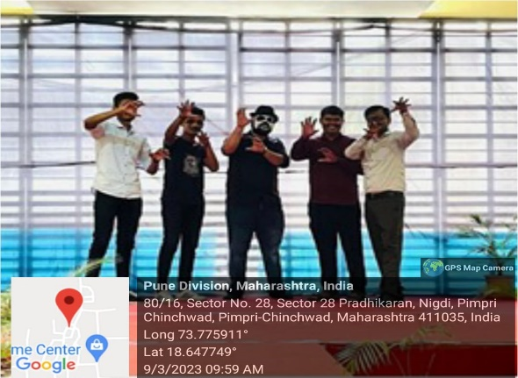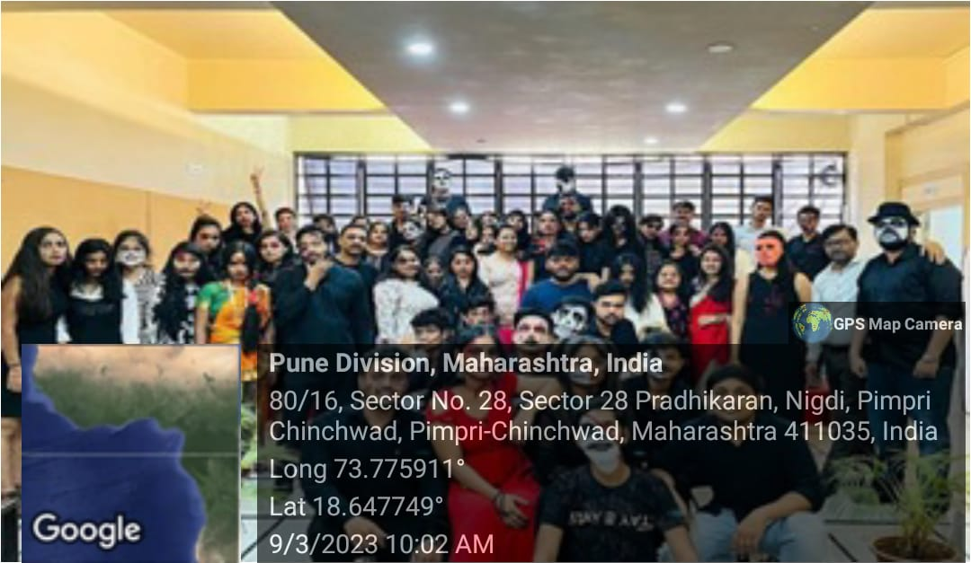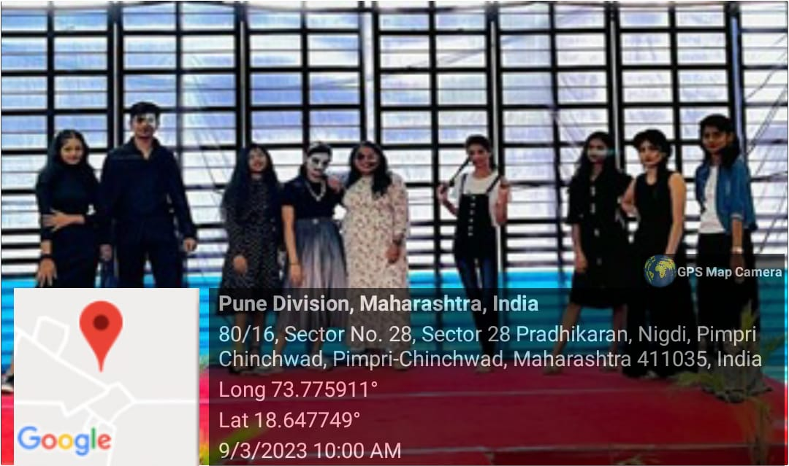**Brief:** Halloween day was celebrated with many activites like face paintings with different theme and mask. Students had worked out the backdrop of the stage in really simpliestic and great aspects. Faculty also participated in the event where students were doing face paiting on the faculties face. Different ghost with horrified drapery, were seen on the day**. The festival has its origin in European countries where the people started dressing up as ghosts believing it will rid them of evil spirits.** The main attractions were the **Halloween characters like monsters, pumpkin, ghosts. The day had to end up with a ramp walk which was organised by students for the faculties as well as for themselves.**

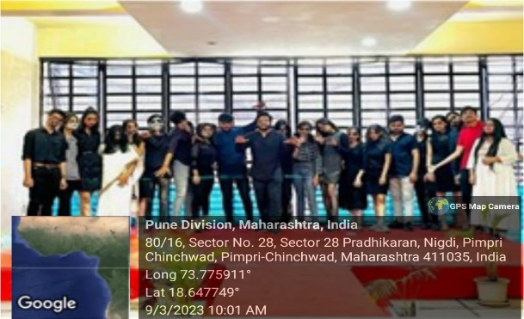

**Photograph of Halloween Day**

**OUTCOME**

Halloween Day, celebrated with enthusiasm on [Date], was a lively and engaging event that brought the spirit of the spooky holiday to PDEA College of Architecture. Here's the outcome of the event:

Creative Activities and Decor: The event featured a variety of activities, including face painting with different themes and mask-making. Students showcased their creativity by designing spooky and imaginative face paintings, while also crafting masks that added to the eerie atmosphere of the celebration. The backdrop of the stage was adorned with simplistic yet captivating decorations, setting the tone for the Halloween-themed festivities.

Faculty Participation and Engagement: Faculty members actively participated in the event, joining students in the face painting activities and embracing the Halloween spirit. This interaction between students and faculty added to the fun and camaraderie of the occasion, fostering a sense of unity and inclusivity within the college community.

Halloween Traditions and Origins: The celebration of Halloween provided an opportunity for students to learn about the origins and traditions of the holiday. Originating from European countries, Halloween has historical roots in warding off evil spirits, and students embraced this tradition by dressing up as ghosts, monsters, pumpkins, and other iconic Halloween characters.

Memorable Ramp Walk: The event concluded with a ramp walk organized by students, allowing participants to showcase their creative costumes and spooky personas. The ramp walk provided a platform for students and faculty to express themselves and display their Halloween-inspired attire, adding to the festive atmosphere of the day.

Overall, the Halloween Day celebration was a resounding success, providing students and faculty with an opportunity to immerse themselves in the spooky festivities and embrace the spirit of Halloween. The event promoted creativity, engagement, and cultural awareness, leaving a lasting impression on all who participated

**REPORT ON TRADITIONAL DAY**

**Date:** 10 March 2023

**Organized by:** PDEA’S College of Architecture

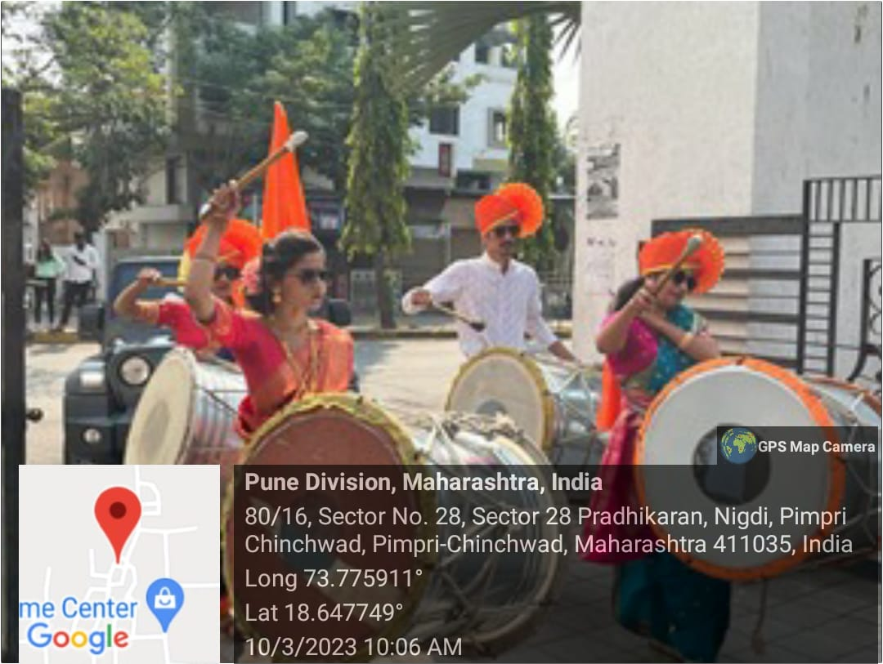**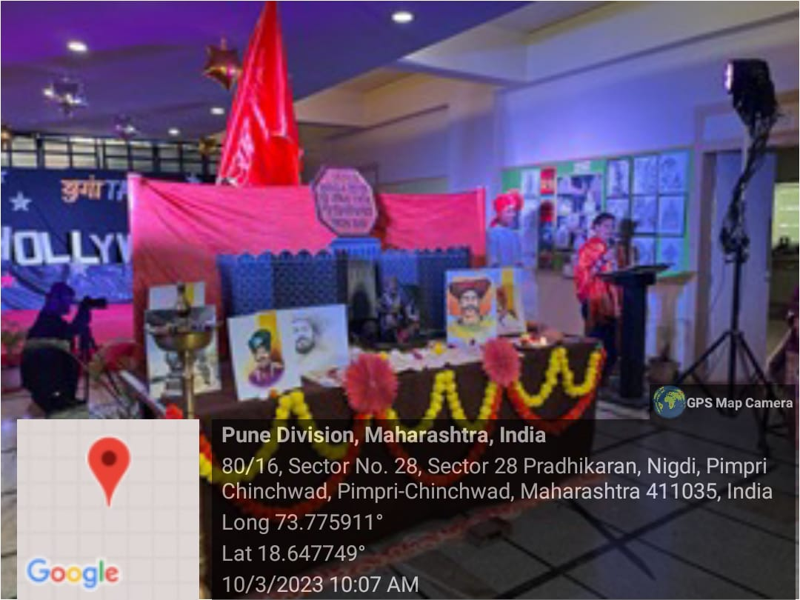Brief:** Traditional day was celebrated on a very auspicious day, as it was Chhatrapati Shivaji Maharaj Jayanti on that day. Students with great enthusium had planned for Chhatrapati Shivaji Maharaj Miravnuk with Dhol and Tasha. They also perfomed so cultural dance on the event. It ended up with an Arti of Maharaj and group photo of well dresses students with different cultures. Students had adopted different cultures from India and put them in one shell of PDEA College of Architecture.

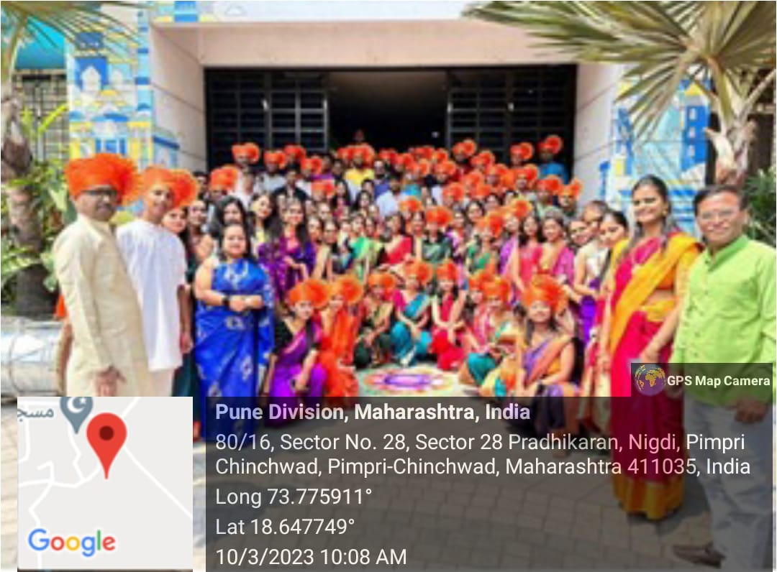

**Photograph of Traditional Day**

**OUTCOME**

The Traditional Day celebration, held on the auspicious occasion of Chhatrapati Shivaji Maharaj Jayanti, was a vibrant and culturally rich event that showcased the diversity and unity of PDEA College of Architecture. Here's the outcome of the event:

Cultural Performances: Students exhibited great enthusiasm and creativity by organizing a spectacular Chhatrapati Shivaji Maharaj Miravnuk, complete with traditional Dhol and Tasha performances. Additionally, cultural dances representing various regions and traditions of India added color and vibrancy to the event. The performances captivated the audience and highlighted the cultural heritage of the country.

Unity in Diversity: The celebration emphasized the importance of unity in diversity, with students embracing different cultures and traditions from across India. Through their attire, performances, and cultural displays, students showcased the rich tapestry of Indian culture and demonstrated the spirit of inclusivity and acceptance within the college community.

Respectful Tribute: As the event coincided with Chhatrapati Shivaji Maharaj Jayanti, students paid homage to the great Maratha warrior through an Arti ceremony, expressing reverence and respect for his legacy. The Arti served as a symbolic gesture of gratitude and remembrance, honoring the values and ideals upheld by Chhatrapati Shivaji Maharaj.

Cultural Exchange: The Traditional Day celebration provided a platform for cultural exchange and dialogue, allowing students to learn from one another and deepen their understanding of India's diverse heritage. By coming together to celebrate different cultures, students fostered a sense of unity, mutual respect, and appreciation for the rich tapestry of traditions that define the country.

Group Photo: The event concluded with a group photo of well-dressed students representing various cultures, symbolizing the unity and harmony within the college community. The photo captured the spirit of togetherness and camaraderie that prevailed throughout the celebration, serving as a cherished memento of the memorable event.

Overall, the Traditional Day celebration was a resounding success, promoting cultural diversity, unity, and mutual respect among students. The event provided a platform for students to showcase their cultural heritage, celebrate traditions, and forge meaningful connections, enriching the college experience for all participants

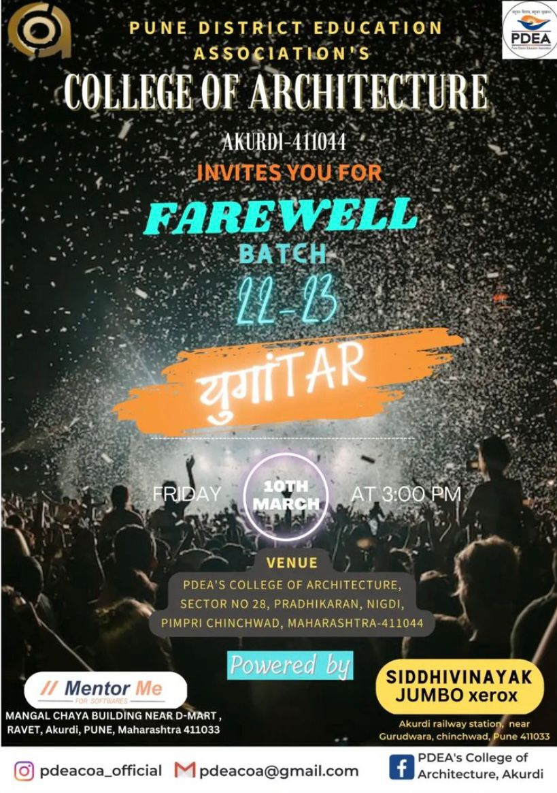

**FAREWELL PARTY 2022-23**

**(BATCH 2017 - 2018)**

**Date:** 11 March 2023

**Organized by:** PDEA’S College of Architecture

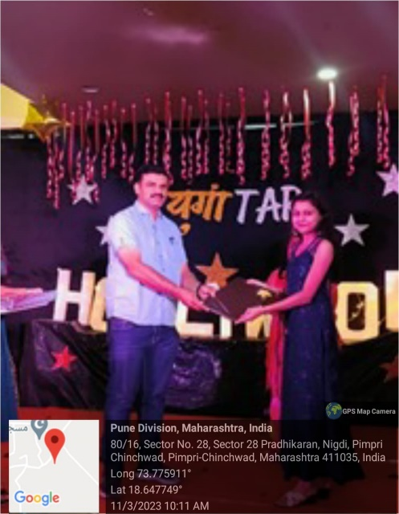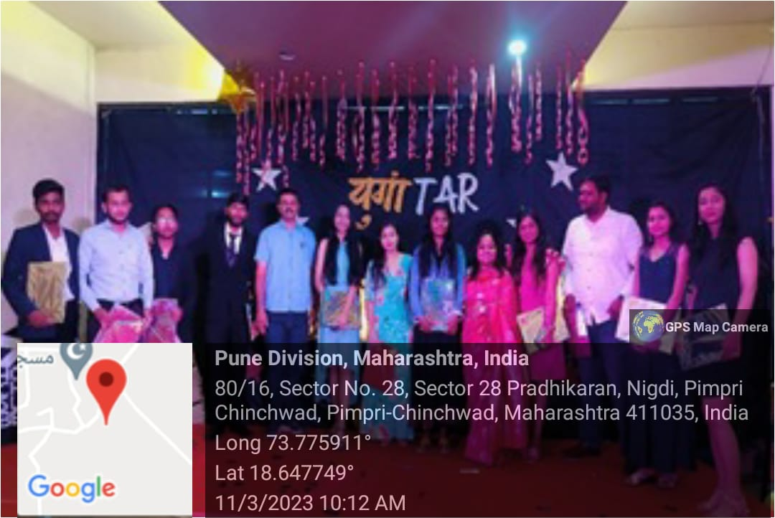**Brief:** A memorable day in the history of PDEA college of Architecture, Pune. A farewell party was organized for the pass out batch. The students were excited as they had come after a long time to the college. The Farewell party started at 7:30 PM with our two anchors from our Fourth Year students. They started with welcome speech formally, welcomed our chief guest Mr. Pramod Jadhav, Principal of Mhalsakant English Medium School, our Principal, HOD and Teaching & Non-teaching staff. Later after introduction to cheer up the students there was a ramp walk planned for them. Small gesture in form of prizes were given to students. The photo frame of the entire journey of 5 years. A memorable gift given the college to the students. The awards were yet to declare. Three awards for the topper, runner-up & best student of the year. There was a surprise DJ planned for the batch. At the end, everyone enjoyed the celebrations and all thanked the HOD, faculties and for hosting such a nice program that they could cherish lifelong.

**Photograph of Farewell Event Report by: Ar. Gayatri Khaire & Ar. Kajal Sawant**

**OUTCOME**

The Farewell Party was a bittersweet celebration that marked the end of our college journey. It was a memorable evening filled with laughter, nostalgia, and heartfelt goodbyes, reinforcing the bonds we've built over the years. As a student, it gave us a sense of closure and gratitude for the experiences and friendships we've cherished during our time here.